Lab No. 01

1. Read Built-in Dataset from Scikit-Learn
In this task, the Iris dataset is loaded from Scikit-Learn.
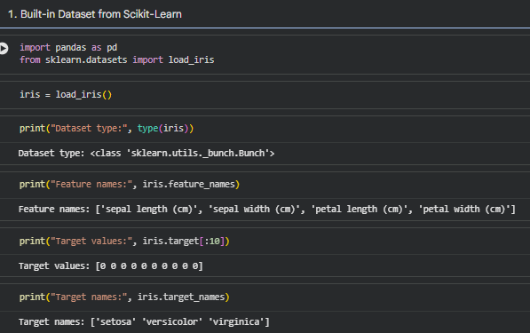
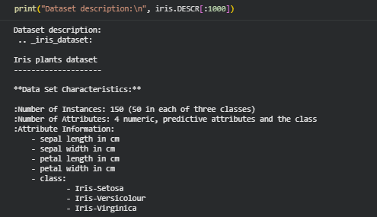
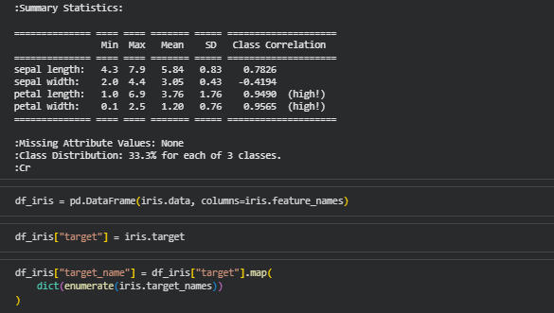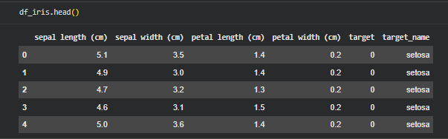

2. Download Dataset from UCI Website
In this task, the Iris dataset is downloaded from the UCI Machine Learning Repository and stored into a Pandas DataFrame.
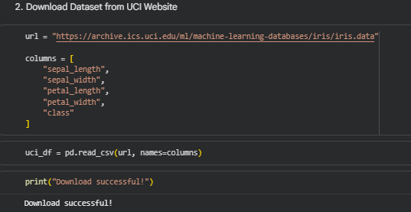
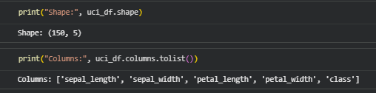

3. Read Data from Computer Files
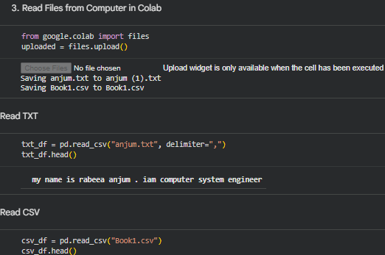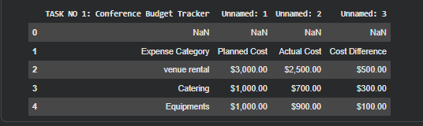

4. Read Different Data Formats into Pandas DataFrame
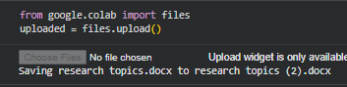
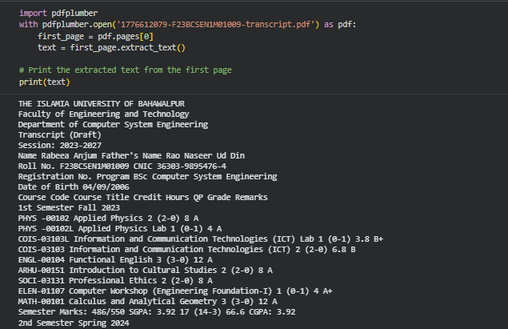
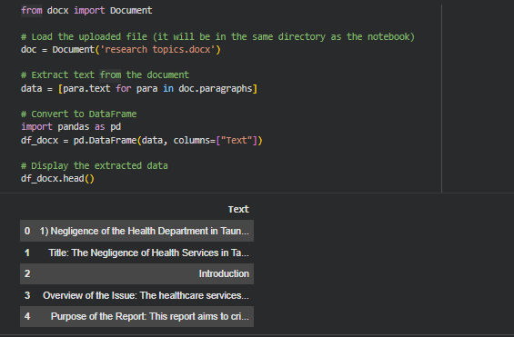

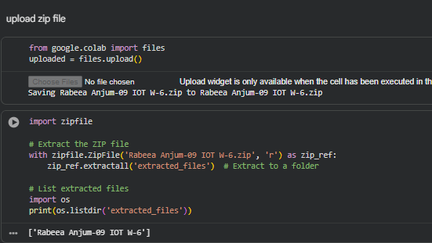
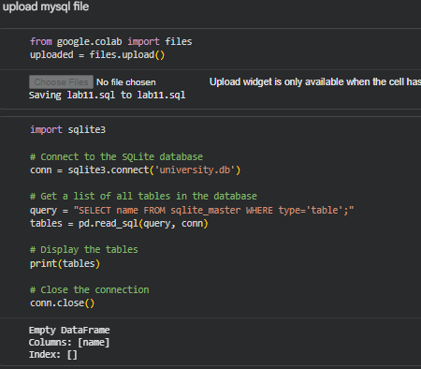

5. Web Scraper to Extract Data from Website
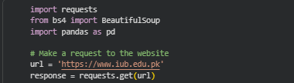

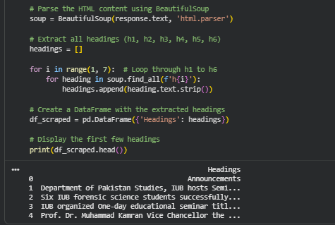

Home Work

1. Sources from Where Datasets Can Be Downloaded
Datasets can be downloaded from the following sources:
- Kaggle
- UCI Machine Learning Repository
- Google Dataset Search
- Data.gov
- World Bank Open Data
- WHO Data Portal
- UNICEF Data
- GitHub repositories
- OpenML
- Scikit-Learn built-in datasets
- Statista
- Yahoo Finance
- Quandl / Nasdaq Data Link
- Academic research repositories
- Government open data portals

2. Explore read_csv() Parameters
The read_csv() function is used to read CSV files into a Pandas DataFrame.

Common Parameters of read_csv()
pd.read_csv(filepath_or_buffer)
Parameter | Purpose
filepath_or_buffer | File path or URL of the CSV file
sep | Defines separator, such as comma, tab, or pipe
delimiter | Alternative to sep
header | Row number to use as column names
names | Custom column names
index_col | Column to use as row index
usecols | Select specific columns
dtype | Define data type of columns
skiprows | Skip specific rows
nrows | Read limited number of rows
na_values | Define values to treat as missing
parse_dates | Convert columns into date format
encoding | File encoding such as UTF-8
low_memory | Handles mixed data types in large files

